Life Cycle Assessment for Anaerobic Digestion Process Treating Source Separated Food Waste Generated in Local Municipalities in Sri Lanka.
B. K. T. Samarasiri^{1,*}, P. G. Rathnasiri¹, S. H. P. Gunawardena¹
¹ Department of Chemical and Process Engineering, University of Moratuwa, Moratuwa, Sri Lanka
* Tel: +94 71 1402908, E-mail: mr.kasun.samarasiri@ieee.org
1.0 Introduction
Municipal solid waste (MSW) is a growing problem in urban cities in Sri Lanka due to socio-economic and environmental aspects of the solid waste management systems in Sri Lanka. Municipal solid waste typically consists of short term biodegradable wastes, long term biodegradable wastes, polythene and plastic wastes, metal wastes, wooden wastes, glass wastes, paper wastes, building wastes, slaughterhouse wastes, saw dust, paddy husk, and cloth, garment wastes and other wastes [1]. The short term biodegradable wastes of MSW consists of 50% - 60% of total waste generation in Sri Lanka and it leads different socio-economic and environmental issues in management of short term bio degradable wastes in different urban areas.
In current scenario, the short term biodegradable waste is managed through composting, landfilling and waste to energy via incineration while in a very few local authorities waste to energy via anaerobic digestion is carried out [2]. The composition of MSW varies due to the different socio-economic and environmental aspects of people living in different local authorities such as municipal councils, urban councils and pradeshiyasabhas in Sri Lanka. Therefore, a generalized life cycle assessment model should be developed for the biomethane production from a fraction of short term biodegradable waste of MSW in different local authorities in Sri Lanka in order to consider economic viability and impact on social and environmental aspects.
According to the previous studies, it has been found that the current MSW generation in Sri Lanka is more than 3000 MT per day and it increases with different socio-economic factors such as population growth, urbanization, consumerism, industrialization, etc. Leachate generated from open dumping sites enters into natural water bodies leading to community health problems [3]. Therefore, conversion of short term biodegradable waste to energy via anaerobic digestion combined with other conventional waste management strategies such as composting, landfilling, waste-to-energy via incineration could be a promising solution for the MSW problem in Sri Lanka.
Previous researches conducted on biomethane production from MSW in Sri Lanka concluded that physicochemical properties of short term biodegradable MSW varies according to the source separation, population growth, seasonal changes (dry and rainy season) [4], cultural ceremonies and etc. The biomethane potential of short term biodegradable MSW changes mainly with its physicochemical properties and other factors such as feed flow rate, dilution rate, operating temperature, inhibitory effects, nutrient deficiency, etc. According to the process conditions, the operational costs, maintenance costs, source separation, solid waste storage facilities, volume of anaerobic reactors, gas storage facilities, power generation facilities, labour force, etc. are varied. To be able to calculate the amount of energy generated from the anaerobic process, factors such as biogas production rate, methane composition in biogas, energy conversion efficiency from biogas to electricity, electricity required for heat effluent, etc. should be considered.
2.0 Objectives
- Estimation of composition and physicochemical characteristics of source separated food waste generated in local authorities in Sri Lanka.
- Development of life cycle assessment model to analyse the impact on socio-economic and environmental aspects of biomethane production from MSW.
- Evaluation of potential of power generation from anaerobic digestion via source separated food waste in MSW.
4.0 Methodology
Life cycle assessment (LCA) is the evaluation of the inputs, outputs and environmental impacts associated with a product system during its life cycle. According to the ISO 14040 on “Environmental management - Life cycle assessment - Principles and framework”, the LCA includes life cycle inventory analysis (LCI) phase, life cycle impact assessment (LCIA) phase and life cycle interpretation phase as shown in the Figure 1. In the LCI, quantification of inputs and outputs of a product system throughout its life cycle is performed. In the LCIA, magnitude of potential environmental impacts of a product system throughout its life cycle is analysed. In life cycle interpretation, findings of either the LCI or the LCIA or both are evaluated in relation to the defined scope to present the conclusions and recommendations.
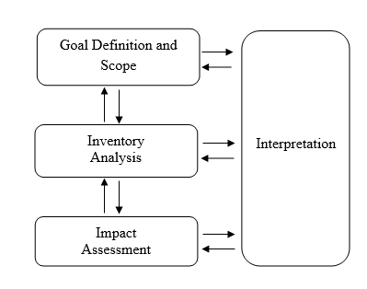
Figure 1: Life Cycle Analysis Process

4.1 Goal Definition and Scope
The goal of this study is to identify the socio-economic and environmental impact of power generation via anaerobic digestion of source separated food waste generated in municipalities in Sri Lanka. The socio-economic impact is assessed by the potential of power generation via anaerobic digestion process. The environmental impact is assessed by the global warming potential from greenhouse gas emissions. The system boundary is introduced to limit the scope and specifically address the life cycle analysis of the anaerobic digestion of easily biodegradable food waste fraction of MSW.
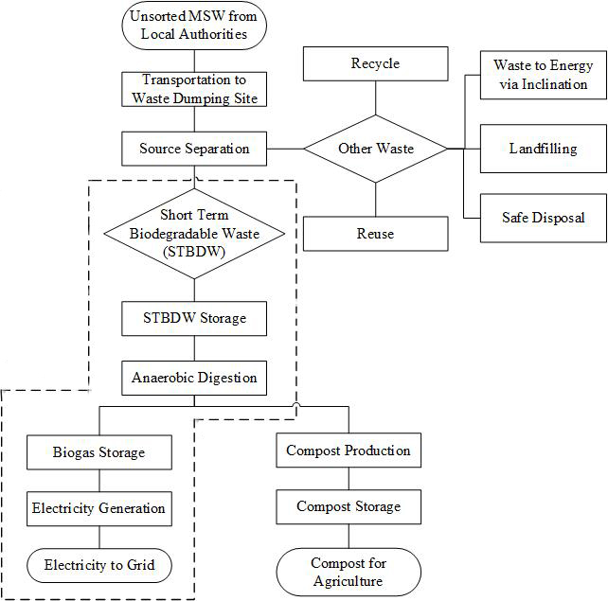
Figure 2: System Boundary for Life Cycle Analysis for the Anaerobic Digestion of MSW
4.2 Life Cycle Inventory Analysis
Life cycle inventory analysis for the short term biodegradable waste generated in Sri Lanka is conducted using the model for anaerobic digestion developed by Paul Harris on 19th April, 2010 (Version 22.2). The model was extensively developed further for life cycle assessment considering socio-economic and environmental aspects such as waste transportation, source separation, labour force, gas storage, carbon dioxide emissions, etc.
The composition and physicochemical characteristics of short term biodegradable MSW varies in different urban areas due to source separation, population growth, social aspects, seasonal changes (dry and rainy season), cultural ceremonies, etc. The composition of short term biodegradable MSW generated from nine provinces [1] in Sri Lanka is given in Table 1.
Table 1: Provincial Gross Weight of Waste Collection and Short Term Bio-degradable Waste Collection in Sri Lanka adopted from “Database of Municipal Solid Waste in Sri Lanka”.
Province | Bio-degradable waste - short term  (kg/day) |  | Percentage of Bio-degradable waste - short term (%) | Gross weight of waste collected (kg/day) | Percentage of Gross weight of waste collected (%)
Western |  | 1040933 | 64.84 | 1662700 | 58.58
Southern |  | 105872 | 6.59 | 198460 | 6.99
Central |  | 139629 | 8.70 | 229223 | 8.08
North Western |  | 58049 | 3.62 | 170189 | 6.00
Sabaragamuwa |  | 53115 | 3.31 | 91860 | 3.24
Uva |  | 47864 | 2.98 | 85660 | 3.02
North Central |  | 32837 | 2.05 | 74132 | 2.61
Eastern |  | 78357 | 4.88 | 232803 | 8.20
Northern |  | 48695 | 3.03 | 93428 | 3.29
Total |  | 1605351 | 100.00 | 2838455 | 100.00
In order to perform the life cycle analysis more specifically, one of the largest open dumping site in Sri Lanka located in Western province is selected. The composition of biodegradable MSW arriving at Karadiyana open dumping site (KODS) in Sri Lanka is shown in the Figure 2. According to the extensive data analysis [5] at KODS (June 2011 – October 2013), total average unsorted MSW arrived at KODS is approximately 550 tons per day. From this unsorted MSW arriving at KODS, food waste consists of 38% from the organic fraction of the total MSW has the best potential to use for the biogas and compost generation via anaerobic digestion as shown in the figure 3.
Food Waste = (Total unsorted MSW*Percentage of Organic fraction of unsorted MSW*
Percentage of food waste of organic fraction of unsorted MSW)
Food waste arrival at KODS = 550 tons/day * (38/100)
= 209 tons/day
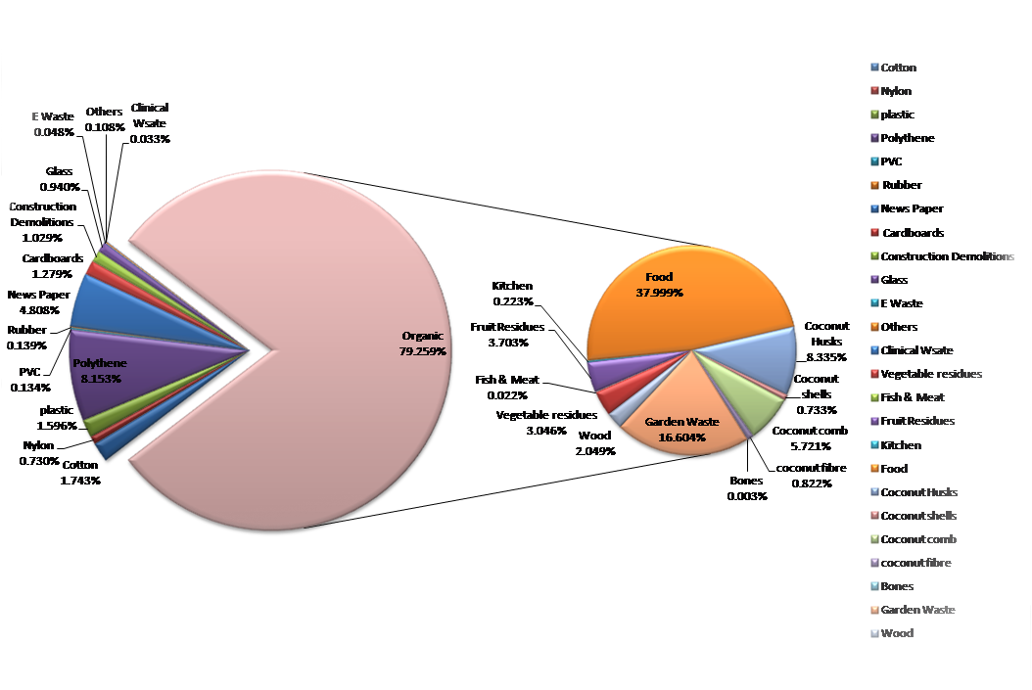
Figure 3: Composition of MSW Arriving at Karadiyana Open Dumping Site
Considering the anaerobic digestion technologies, the main distinction is wet anaerobic digestion systems in which operated at low total solids (<10–20% TS) and dry systems in which operated at high total solids (>20%–40% TS). Both wet and dry anaerobic systems are successfully operated in different countries. Considering the reactor combinations single stage anaerobic digestion is more commonly practiced but two-stage anaerobic digestion is also can be applicable under controlled process conditions. The physicochemical characteristics of typical food waste [6] from MSW is shown in the Table 2.
Table 2: Physicochemical Characteristics of Typical Source Separated Food Slurry
 | Food Slurry
TS (g/l) | 70
TVS (g/l) | 55.6
Fat (%) | 3
Protein (%) | 13
Carbohydrates (%) | 58.5
Even though the food waste of MSW contains a considerable level of moisture, it should be mixed with certain amount of water to make a slurry. Considering the reactor as wet anaerobic system, the percentage of solid in suspension is adjusted to 7% before anaerobic digestion. The average temperature of KODS is 30°C and it does not vary drastically.
According to the modified model, key parameters which directly effect on the life cycle assessment of anaerobic digestion are identified as amount of daily food waste arrival, volatile solid (VS) composition of food waste, conversion efficiency of VS into methane, methane yield, electricity conversion efficiency of the plant, tariffs for electricity produced using non-conventional renewable energy (NCRE), etc. The modified model is further developed considering the key main parameters in anaerobic biodegradation.
The food waste typically contains a certain amount of moisture. Therefore, the solid fraction of the food waste was calculated by considering the total weight of food waste and its moisture content. The volumetric flow rate of the slurry can be calculated by considering the solid fraction of food waste generated per day and the total solid content of the slurry. The digester volume can be evaluated by considering the volumetric flow rate of the slurry, the hydraulic retention time (HRT) and taking 10% volume as head space. The net methane production can be evaluated by considering VS input concentration, operating temperature of the anaerobic reactor, hydraulic retention time and ultimate methane yield for food waste. The electricity generation rate can be evaluated by considering net methane production, calorific value of methane and electricity conversion efficiency.
E = V*CV*η
Where, E = Electricity Generation (MW)
V = Net Methane Production (m³/s)
CV = Calorific Value of Methane (MJ/m³)
η = Power Plant Efficiency (%)
The economic evaluation is conducted using the costing of the anaerobic digester, costing of the power plant, costing of storage such as waste and gas storage, costing of utilities such as electricity usage of crusher, pumps and offices, operational costing such as material cost, labour cost, staff cost, water usage and etc. and maintenance costing. The payback period of the whole plant to evaluate its economic feasibility. The important process parameters taken from the previous research works done one food waste [7] from the MSW and other supportive facts are mentioned in the Table 3.
Table 3: Process Parameters Considered in the Life Cycle Assessment
Parameter | Value
Moisture content of food waste | 63%
Retention time | 11.9 days
Operating temperature | 35 °C
Methane percentage in biogas | 55%
Carbon dioxide percentage in biogas | 30%
Electricity conversion efficiency of the power plant | 25 %
Flat tariff for electricity generation from biogas in Sri Lanka | 0.18 USD
The most critical two parameters in this life cycle analysis are VS reduction efficiency and methane yield. In anaerobic digestion, the VS reduction efficiency and methane yield changes with the operating temperature of the reactor, growth rate of the microorganisms, hydraulic retention time, physicochemical characteristics of the food waste slurry, etc. The model can be applied in order to analyse the economic feasibility and the environmental impact of anaerobic digestion of source separated food waste generated in municipalities in Sri Lanka.
4.3 Life Cycle Impact Assessment
In life cycle impact assessment, mainly the socio-economic and environmental impact of the selected system boundary is considered. In this scenario, anaerobic digestion of food waste of MSW and generate electricity from methane gas is considered as the system boundary. Within this system boundary, there are positive and negative consequences. The carbon dioxide generation can be considered as the main drawback within this system boundary. The net carbon dioxide emission rate can be evaluated by considering the percentage of carbon dioxide in biogas, biogas generation rate and carbon dioxide generation rate after the combustion of methane. The positive socio-economic and environmental aspects of anaerobic digestion of food waste are electricity generation, improving public health and sanitation, landfill leachate elimination, odour elimination, job creation, etc. Therefore, even though a significant amount of carbon dioxide is produced, the anaerobic digestion can be considered as a renewable and environmental friendly energy generation and MSW management process than the fossil fuels.

5.0 Results
The life cycle analysis model was used for the determination of the most important process parameters in anaerobic digestion such as hydraulic retention time, volatile solid reduction efficiency and the methane production as shown in Figure 4,5 and 6.
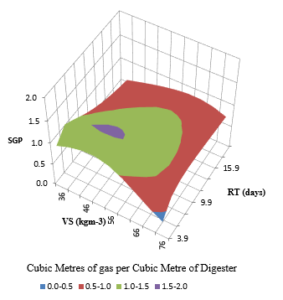
Figure 4: Specific Gas Production Response Surface Graph
According to the Figure 4, when VS concentration is 55.6 kg/m³ the maximum specific gas production occurs within the region of retention time 9.9 days to 17.9 days. Considering safety factors, the recommended retention time generated in the model was 11.9 days.
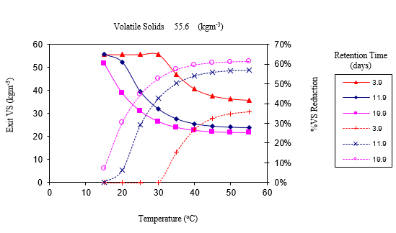
Figure 5: VS Reduction Efficiency vs. Temperature
According to the Figure 5, when VS concentration is 55.6 kg/m³, operating temperature is 35°C and the retention time is 11.9 days, the VS removal efficiency of the anaerobic digestion process is 50%.
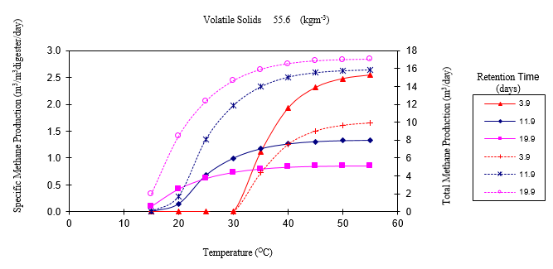
Figure 6: Specific Methane Production vs. Temperature
According to the Figure 6, when VS concentration is 55.6 kg/m³, operating temperature is 35°C and the retention time is 11.9 days, the specific methane production of the anaerobic digestion process is 1.173 m³ methane/m³ of digester. Therefore, the methane yield of the digestion process is 0.25 m³/kgVSSadded.
The life cycle assessment model was conducted to evaluate the socio-economic and environmental feasibility of anaerobic biodegradation of source separated food waste arriving at KODS. The generated assessment result for the KODS is mentioned in the Table 4.
Table 4: LCA Test Result for the Anaerobic Biodegradation of Source Separated Food Waste Arriving at KODS
 | Value
Input food waste | 209000 kg/day
Slurry flow rate | 1104.71 m³/day
Water usage | 973044.29 kg/day
Digester volume | 14460.70 m³
VS reduction efficiency | 50%
Methane yield | 0.25 m³/kgVSS added
Electricity generation | 1621.74 kW
CO2 Generation | 22209.93 m³/day
Initial capital cost | 2971425.59 USD
Net income | 737325.14 USD/year
Payback period | 4.03 years
According to the test results, it can be seen that in order to establish the biogas plant, a large amount of continuous water supply should be there and a large land area is required for the construction of the biogas plant. The payback period is about 4 years’ time period and the net income is about 700000 USD per year without considering the revenue generated by the compost production from the anaerobic sludge. Therefore, the biogas plant for the KODS is socio-economically feasible within this system boundary. Under this process conditions the electricity energy generation potential of the food waste from the KODS is 670.42 kJ per kg of food waste. Considering the whole country, the approximate potential of power generation via source separated food waste is shown in the Table 5. The percentage of food waste of MSW in all areas is assumed as 38% and the physicochemical characteristics of food waste is assumed as same the same as in food waste arriving at KODS.
Table 5: Potential of Power Generation by Biomethane Production via MSW in 2005.
Province | Bio-degradable waste - short term (kg/day) | Food Waste (kg/day) | Potential of Power Generation (kW)
Western | 1040933 | 395554.54 | 3065.547685
Southern | 105872 | 40231.36 | 311.79304
Central | 139629 | 53059.02 | 411.207405
North Western | 58049 | 22058.62 | 170.954305
Sabaragamuwa | 53115 | 20183.70 | 156.423675
Uva | 47864 | 18188.32 | 140.95948
North Central | 32837 | 12478.06 | 96.704965
Eastern | 78357 | 29775.66 | 230.761365
Northern | 48695 | 18504.10 | 143.406775
Total | 1605351 | 610033.38 | 4727.758695
6.0 Conclusion
Anaerobic digestion of source separated food waste has been practiced in many countries around the world to overcome its socio-economic and environmental problems. According to the life cycle assessment done on food waste arriving at KODS, it is obvious that the anaerobic digestion is a promising solution for the management of municipal waste in KODS. It can be also applied into other waste dumping sites to overcome the problems generated by easily biodegradable food waste. The potential of power generation by biomethane production via source separated food waste in whole country is about 5 MW according to the statistics of waste collection in 2005. As mentioned in the introduction, this potential for power generation will increase due to population growth and other socio-economic factors. The conversion of food waste into methane can be used to generate power as well as to overcome socio-economic and environmental issues such as unsanitary conditions around waste disposal areas, reduction of landfill leachate, compost production for agricultural purposes, etc. Therefore, considering the overall scenario, biomethane production via source separated food waste is socio-economically feasible and environmental friendly sustainable approach to manage municipal solid waste in Sri Lanka.
References
1. 2005. Database of Municipal Solid Waste in Sri Lanka. Ministry of Environment and Natural Resources, Sri Lanka, ISBN 9-559-12035-2.
2. Alvis AD (2002) Biogas - a review of Sri Lanka’s performance with a renewable energy technology. Energy for Sustainable Development 6 (1): 30-37
3. Menikpura SNM, Gheewala SH, Bonnet S (2012) Sustainability assessment of municipal solid waste management in Sri Lanka: problems and prospects. Journal of Material Cycles and Waste Management 14 (3): 181–1921.
4. Priyashantha KAS, Ariyawansha RTK, Senevirathne SADN, Basnayake BFA, Chandrasena ASH (2015) Development and performance evaluation of the leachate treatment system at Gohagoda municipal solid waste disposal site. 6th International Conference on Structural Engineering and Construction Management, December 11th - 13th, 2015, Kandy, Sri Lanka.
5. Rathnasiri PG, Abeywarna CI (2015) Proposed Large-Scale Anaerobic Digestion Plant for Treatment of Municipal Solid Waste. Feasibility Report. Department of Chemical & Process Engineering, University of Moratuwa.
6. Rathnasiri PG, Johansen JE, Drangeid CB, Bakke R (2005) Transient co-digestion plant behavior. 4th International Symposium, Anaerobic Digestion of Solid Waste, August 31th- September 2nd, 2005, Copenhagen, Denmark.
7. Rathnasiri P.G. (2016) Dynamic modelling and simulation of pilot scale anaerobic digestion plant treating source separated food waste and effect of recycling sludge. Procedia Environmental Sciences 35: 740–748.

